---------------------------------------------------------------------

-- LAB 03

--

-- Exercise 4

---------------------------------------------------------------------

USE TSQL;

GO

---------------------------------------------------------------------

-- Task 1

1-- Write a SELECT statement to display the categoryid and productname columns from the Production.Products table.

---------------------------------------------------------------------

---------------------------------------------------------------------

-- Detyre 1

1-- Selektoni kolonat categoryid and productname nga tabela Production.Products.

---------------------------------------------------------------------

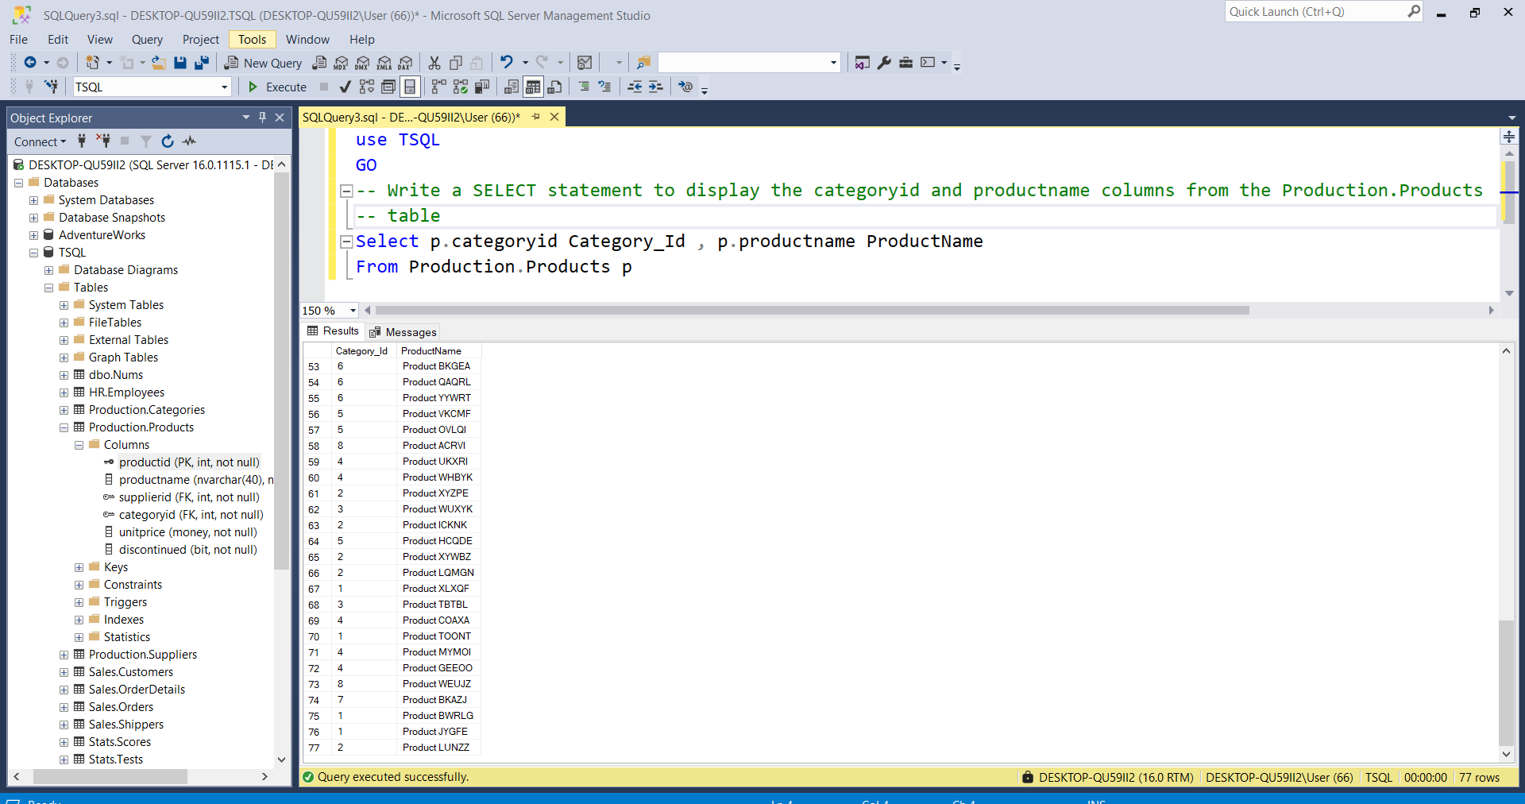

---------------------------------------------------------------------

-- Task 2

-- Enhance the SELECT statement in task 1 by adding a CASE expression that generates a result column named categoryname. The new column should hold the translation of the category ID to its respective category name, based on the mapping table supplied earlier. Use the value “Other” for any category IDs not found in the mapping table.

---------------------------------------------------------------------

---------------------------------------------------------------------

-- Detyre 2

-- shkruani te njejtat veprime si ne Detyren 1 duke shtuar nje CASE expression qe gjeneron si rezultat nje kolone te quajtur *categoryname*. Kolona e re duhet te mbaje perkthimin e kategorise ID respektivisht me kategorine name, bazuar ne tablen mapping te dhene. Perdor vleren “Other” per cdo kategori te IDs qe nuk gjendet ne tabelen mapping.

---------------------------------------------------------------------

Select pP.categoryid Category_Id , pC.categoryname CategoryName,

pP.productname ProductName,

case when pP.categoryid='' then 'pC.categoryname'

else 'OTHER' END as [nuk_ekziston]

From Production.Products pP INNER JOIN Production.Categories pC ON pP.categoryid=pC.categoryid

---------------------------------------------------------------------

-- Task 3

-- Modify the SELECT statement in task 2 by adding a new column named iscampaign. This will show the description “Campaign Products” for the categories Beverages, Produce, and Seafood and the description “Non-Campaign Products” for all other categories.

---------------------------------------------------------------------

---------------------------------------------------------------------

-- Detyre 3

-- Ndryshoni veprimet ne Detyren 2 Duke shtuar nje kolone te re te quajtur iscampaign. Kjo do te shfaqe pershkrimin “Campaign Products” per kategorite Beverages, Produce, dhe Seafood dhe pershkrimin “Non-Campaign Products” per te gjitha kategorite e tjera.

